Aa

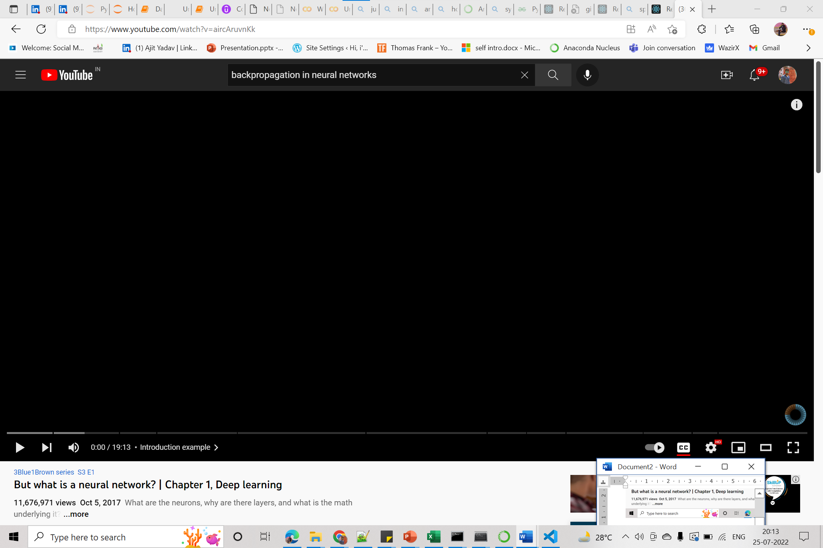













[DS22JULY - 22 July Lecture 3 (2022-07-24 05:30 GMT-7) - Google Drive](https://drive.google.com/file/d/1UZ7lyWl-qtBbrcZHJISe1g195vKu8hB9/view)

